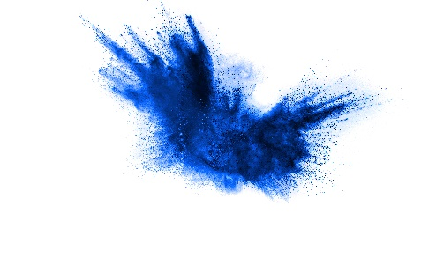
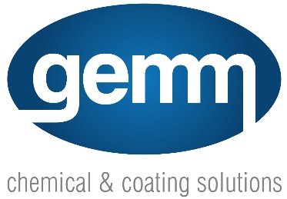

Technical Data Sheet (TDS)

Product Name: Algae B Gone

Description:
Algae B Gone is a powerful non-chlorine liquid treatment specifically designed to eliminate algae, mildew, and bacteria. Formulated with care, it offers efficient eradication while being safe for various surfaces.

Directions for Use:
- Algae:: Mix 1 part Algae B Gone with 20 parts water.
- Moss & Lichen:: Mix 1 part Algae B Gone with 5 parts water.
Ensure the treated area will not be affected by rainfall. Liberally spray onto the surface and leave to act.

Recommended Applications:
- Slipways
- Concrete paths
- Painted surfaces
- Artificial grass
- Fountains
- Air conditioning cooling towers

Active Constituent:
- 150g/L Alkyl Dimethyl Benzyl Ammonium Chloride

Safety Precautions:
- WARNING: Not to be ingested. Keep out of reach of children. Read Safety Data Sheet (SDS) and safety instructions before use.
- Dilution rates may vary depending on the application.
- Prolonged use requires wearing gloves.
- Avoid contact with eyes. In case of contact, flush eyes continuously with running water for at least 15 minutes. Seek medical attention.
- If swallowed, do not induce vomiting. Give a glass of water and seek medical attention immediately. Contact Poison Information Centre (Ph. 13 11 26 from anywhere in Australia) or a doctor.
- Please recycle packaging by returning clean containers to a recycler or designated collection point.

Hazard Statements:
- H303: May be harmful if swallowed.
- H315: Causes skin irritation.

Manufacturer:
Left Pillar Pty Ltd T/A Shield Chemicals

Distributed by:
Gemm Pty Ltd
ABN 98 074 653 035
Unit 3, 238-244 Edwardes Street, Reservoir VIC 3073
E: orders@gemmchemicals.com.au
W: gemmchemicals.com.au

Note: This TDS is provided for informational purposes. Users are advised to read and understand the SDS and safety instructions before operating or using the product. Dilution rates may vary depending on specific applications.

