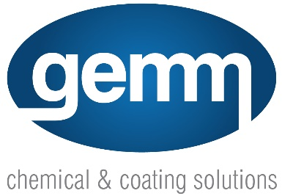

Technical Data Sheet (TDS)

Product Name: Alubright

Description: Alubright is an effective cleaner and brightener for most metals, including aluminium and stainless steel. It effectively removes scale and aluminium oxide, leaving surfaces clean and bright. Alubright is suitable for general cleaning purposes as well as cleaning air-conditioning condensers.

Directions for Use:
- For general cleaning: Dilute 1 part Alubright with 20 parts water.
- For air-conditioning condensers: Dilute 1 part Alubright with 10 parts water.
- Allow Alubright to dwell on the surface for 1-2 minutes, then rinse off thoroughly with water.

Active Constituents:
- Hydrochloric Acid (concentration < 20%)
- Ammonium Hydrogen Bifluoride (concentration < 5%)

Hazard Classification:
- Hazard Statements: H302 Harmful if swallowed, H314 Causes severe skin burns and eye damage, H335 May cause respiratory irritation.

Warning:
- Not to be taken internally.
- Keep out of reach of children.
- Read SDS (Safety Data Sheet) & safety instructions before operating or using.

Note:
- Dilution rates may vary depending on the application. The provided directions are suggestions, and in some cases, weaker or stronger dilutions may apply.

Safety Precautions:
- Prolonged use: Wear gloves.
- Avoid contact with eyes and skin.
- First Aid:
- If swallowed, DO NOT induce vomiting. Give a glass of water and seek medical attention immediately. Contact Poisons Information Centre (Ph. 13 11 26 from anywhere in Australia) or a doctor.
- If in eyes, hold eyelids apart and flush the eye continuously with running water for at least 15 minutes or until advised to stop by the Poisons Information Centre or a doctor.

Manufacturer:
- Left Pillar Pty Ltd T/A Shield Chemicals
- Distributed by Gemm Pty Ltd
- ABN 98 074 653 035
- Unit 3, 238-244 Edwardes Street, Reservoir VIC 3073
- Email: orders@gemmchemicals.com.au
- Website: gemmchemicals.com.au

